Lab 3
Areesha Raheel
55039
Problem solving

Lab Tasks:
1. Write a program to determine if an undirected graph contains a clique of size k. A clique is a subset of vertices where every two distinct vertices are connected by an edge.
Input:
- A graph represented as an adjacency matrix (2D list graph where graph[i][j] = 1 if there is an edge between vertex i and j, else 0).
- An integer k (the target clique size).
Output:
Return True if the graph contains a clique of size ≥ k, otherwise False.
Example:
graph = [
[0, 1, 1],
[1, 0, 1],
[1, 1, 0]
]
k = 3
# Output: True (The entire graph is a clique of size 3)
Code:
#include <iostream>
#include <vector>
using namespace std;

// Check if selected vertices form a clique
bool isClique(vector<vector<int>> &graph, vector<int> &subset) {
for (int i = 0; i < subset.size(); i++) {
for (int j = i + 1; j < subset.size(); j++) {
if (graph[subset[i]][subset[j]] == 0)
return false;
}
}
return true;
}

// Generate combinations
bool findClique(vector<vector<int>> &graph, int k, int start, vector<int> &subset, int n) {
if (subset.size() == k) {
return isClique(graph, subset);
}

for (int i = start; i < n; i++) {
subset.push_back(i);
if (findClique(graph, k, i + 1, subset, n))
return true;
subset.pop_back();
}
return false;
}

int main() {
vector<vector<int>> graph = {
{0,1,1},
{1,0,1},
{1,1,0}
};

int k = 3;
int n = graph.size();
vector<int> subset;

if (findClique(graph, k, 0, subset, n))
cout << "YES, clique exists\n";
else
cout << "NO clique\n";

return 0;
}
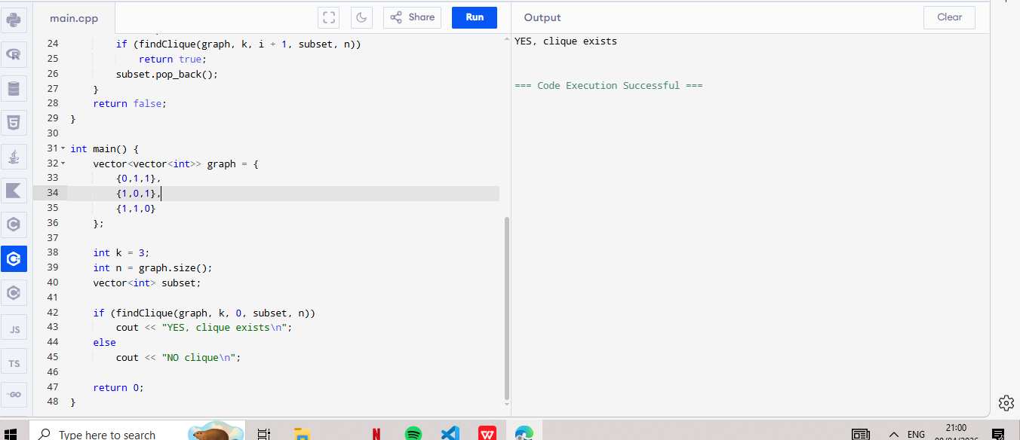

2. Write a program to find the size of the largest clique in an undirected graph.
Input:
- A graph represented as an adjacency matrix.
Output:
Return the size of the maximum clique (integer).
Example:
graph = [
[0, 1, 1, 0],
[1, 0, 1, 1],
[1, 1, 0, 1],
[0, 1, 1, 0]
]
# Output: 3 (Clique: {0, 1, 2} or {1, 2, 3})
Code:
#include <iostream>
#include <vector>
using namespace std;

bool isClique(vector<vector<int>> &graph, vector<int> &subset) {
for (int i = 0; i < subset.size(); i++) {
for (int j = i + 1; j < subset.size(); j++) {
if (graph[subset[i]][subset[j]] == 0)
return false;
}
}
return true;
}

bool findClique(vector<vector<int>> &graph, int k, int start, vector<int> &subset, int n) {
if (subset.size() == k)
return isClique(graph, subset);

for (int i = start; i < n; i++) {
subset.push_back(i);
if (findClique(graph, k, i + 1, subset, n))
return true;
subset.pop_back();
}
return false;
}

int maxCliqueSize(vector<vector<int>> &graph) {
int n = graph.size();
vector<int> subset;

for (int k = n; k >= 1; k--) {
if (findClique(graph, k, 0, subset, n))
return k;
}
return 0;
}

int main() {
vector<vector<int>> graph = {
{0,1,1,0},
{1,0,1,1},
{1,1,0,1},
{0,1,1,0}
};

cout << "Maximum Clique Size: " << maxCliqueSize(graph) << endl;

return 0;
}
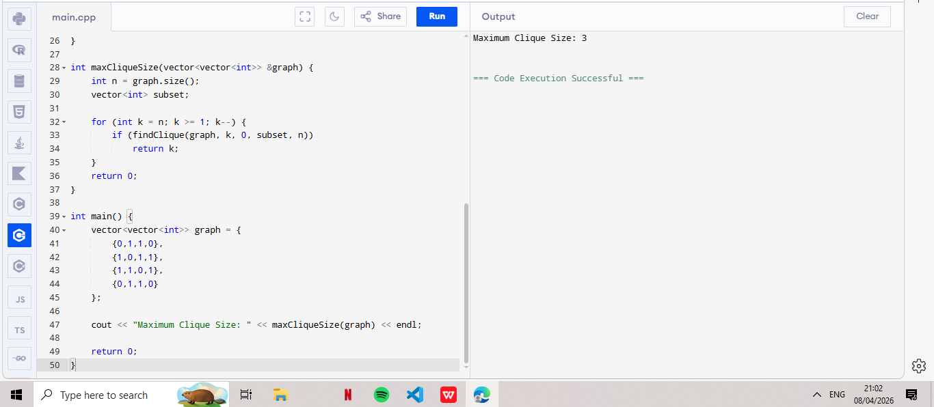
3. Write a program to list all maximal cliques in a graph. A maximal clique is a clique that cannot be extended by adding another vertex.
Input:
- A graph represented as an adjacency matrix.
Output:
Return a list of sets, where each set represents a maximal clique.
Example:
graph = [
[0, 1, 0, 0],
[1, 0, 1, 0],
[0, 1, 0, 1],
[0, 0, 1, 0]
]
# Output: [{0, 1}, {1, 2}, {2, 3}]
Code:

#include <iostream>
#include <vector>
using namespace std;

// Function to print clique
void printClique(vector<int> &clique) {
cout << "{ ";
for (int v : clique)
cout << v << " ";
cout << "}\n";
}

// Check if vertex can be added
bool canAdd(vector<vector<int>> &graph, vector<int> &clique, int v) {
for (int u : clique) {
if (graph[u][v] == 0)
return false;
}
return true;
}

// Backtracking for maximal cliques
void findMaximalCliques(vector<vector<int>> &graph, vector<int> &clique, int start, int n) {
bool isMaximal = true;

for (int i = start; i < n; i++) {
if (canAdd(graph, clique, i)) {
clique.push_back(i);
findMaximalCliques(graph, clique, i + 1, n);
clique.pop_back();
isMaximal = false;
}
}

if (isMaximal && !clique.empty()) {
printClique(clique);
}
}

int main() {
vector<vector<int>> graph = {
{0,1,0,0},
{1,0,1,0},
{0,1,0,1},
{0,0,1,0}
};

int n = graph.size();
vector<int> clique;

cout << "Maximal Cliques:\n";
findMaximalCliques(graph, clique, 0, n);

return 0;
}
